## **Day 5 Presidio Assignment Screenshots:**

Employee management:

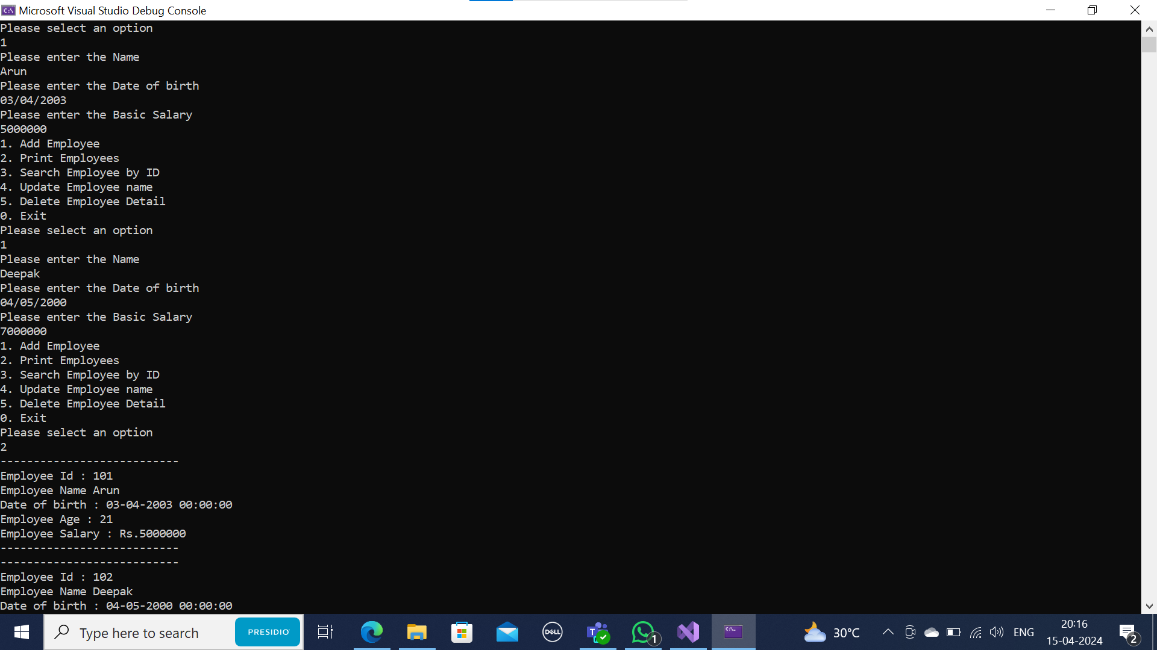

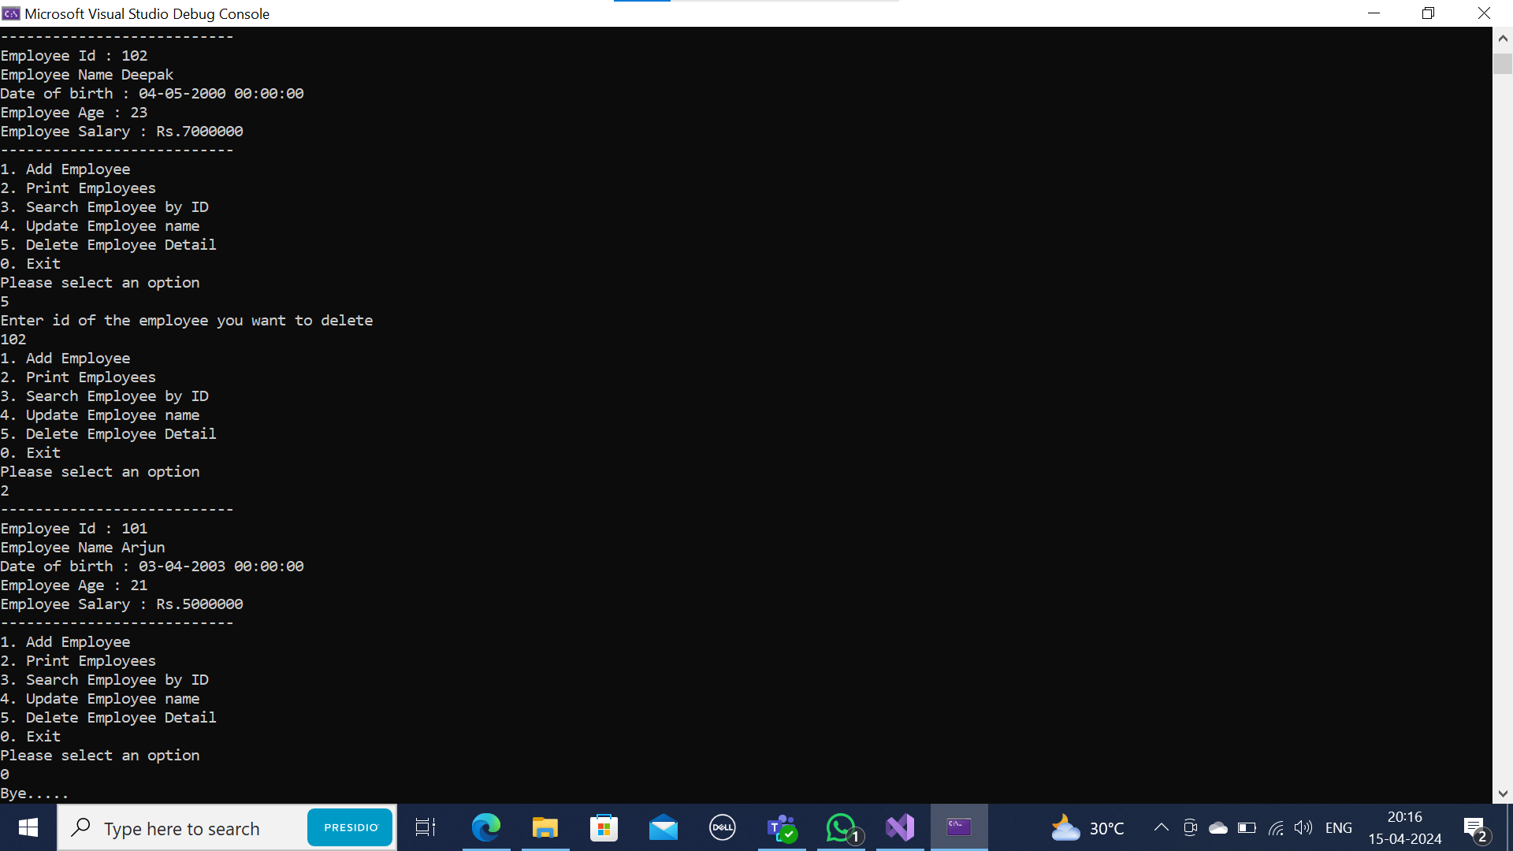

Cows and bulls Programming:

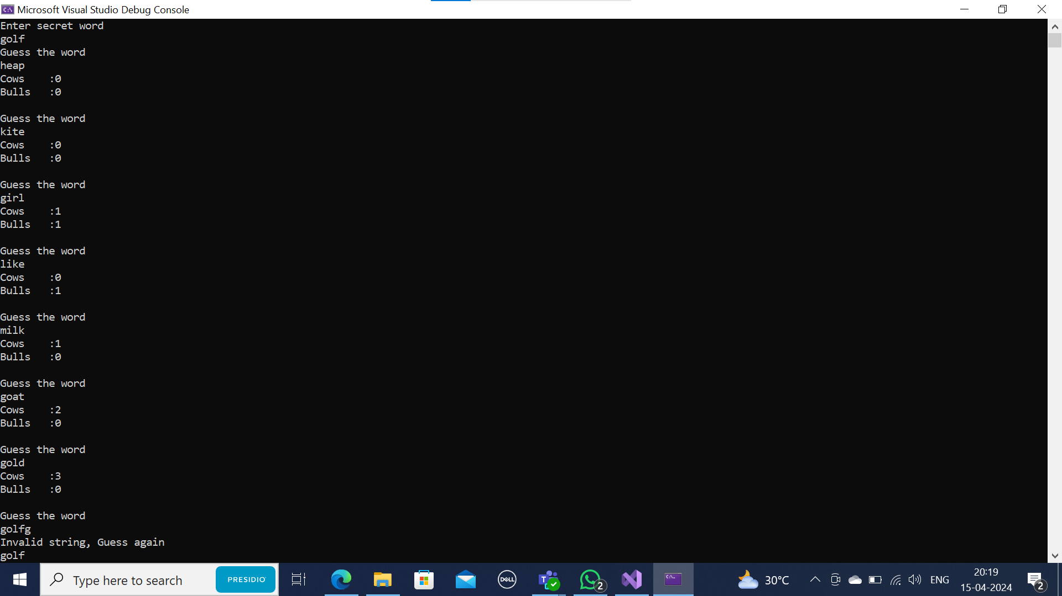

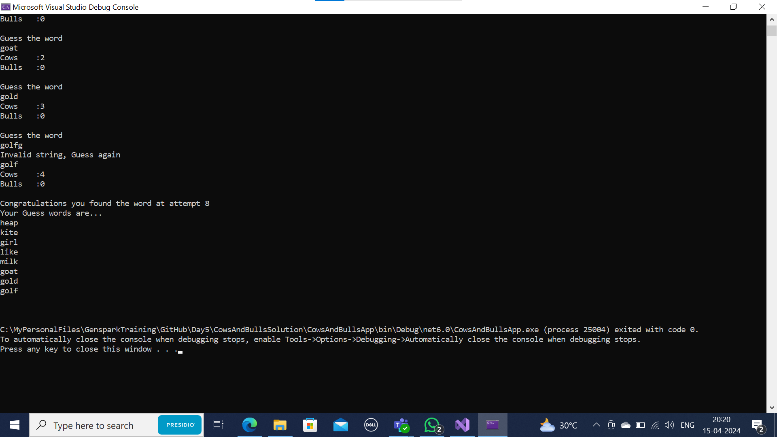

Cows and bulls Leetcode program: [Bulls and Cows - LeetCode](https://leetcode.com/problems/bulls-and-cows/submissions/1233020011/)

